August 22, 2021 10 AM: The Holy Eucharist: Rite Two

The Thirteenth Sunday after Pentecost

Prelude

The Entrance Hymn: 408 Sing praise to God who reigns above

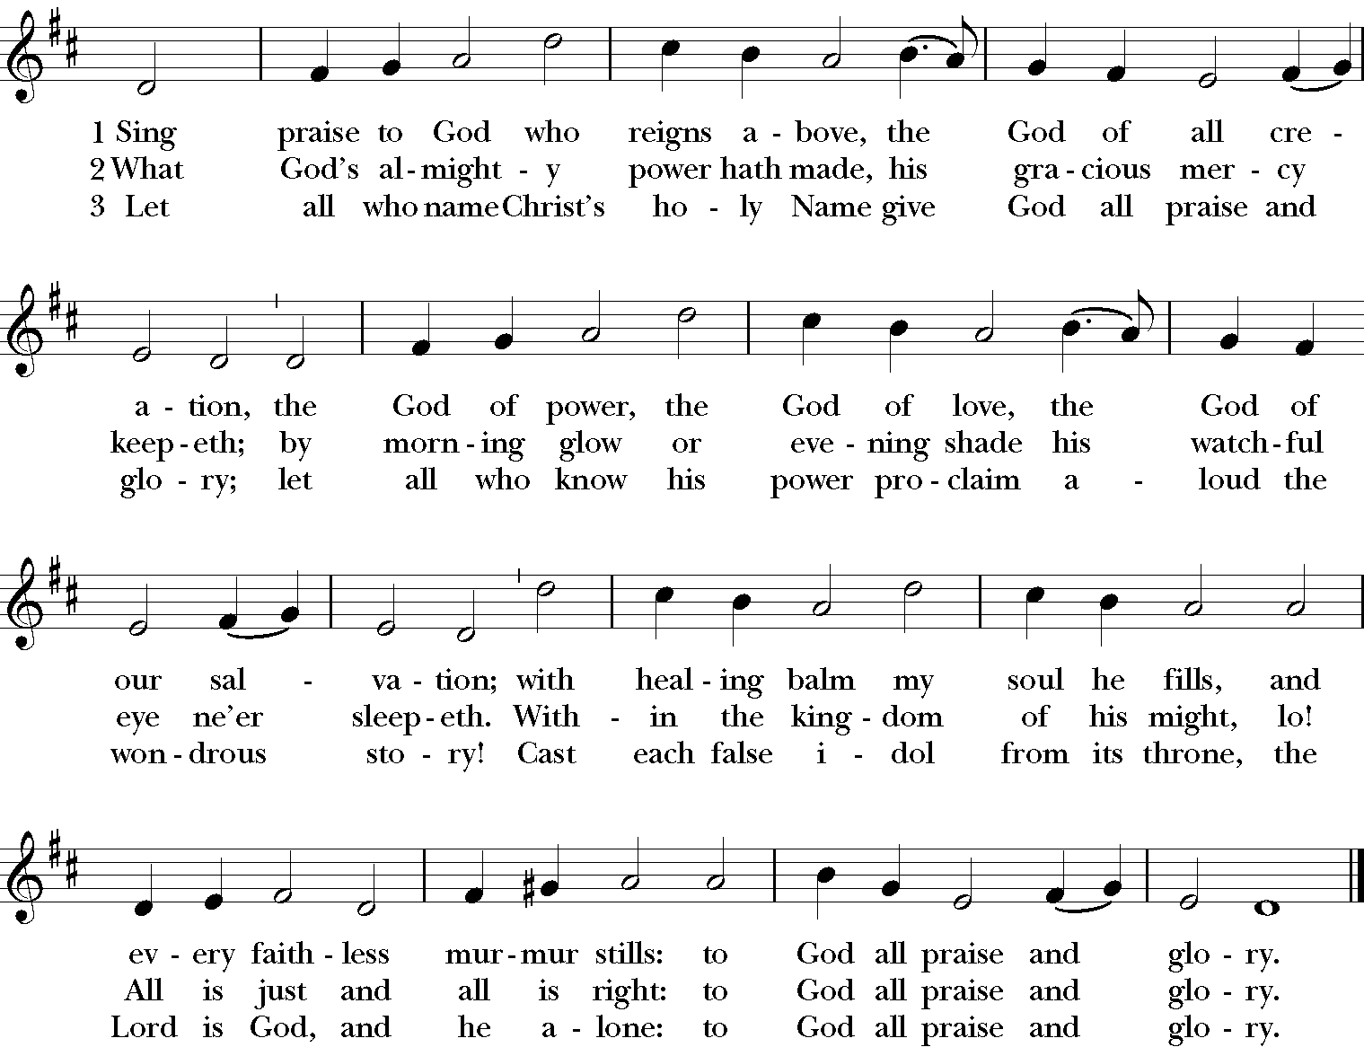

The Word of God (page 355 BCP)
Celebrant: | Blessed be God: Father, Son, and Holy Spirit.
All: | And blessed be his kingdom, now and for ever. Amen.
Celebrant: Almighty God, to you all hearts are open, all desires known, and from you no secrets are hid: Cleanse the thoughts of our hearts by the inspiration of your Holy Spirit, that we may perfectly love you, and worthily magnify your holy Name; through Christ our Lord. Amen.
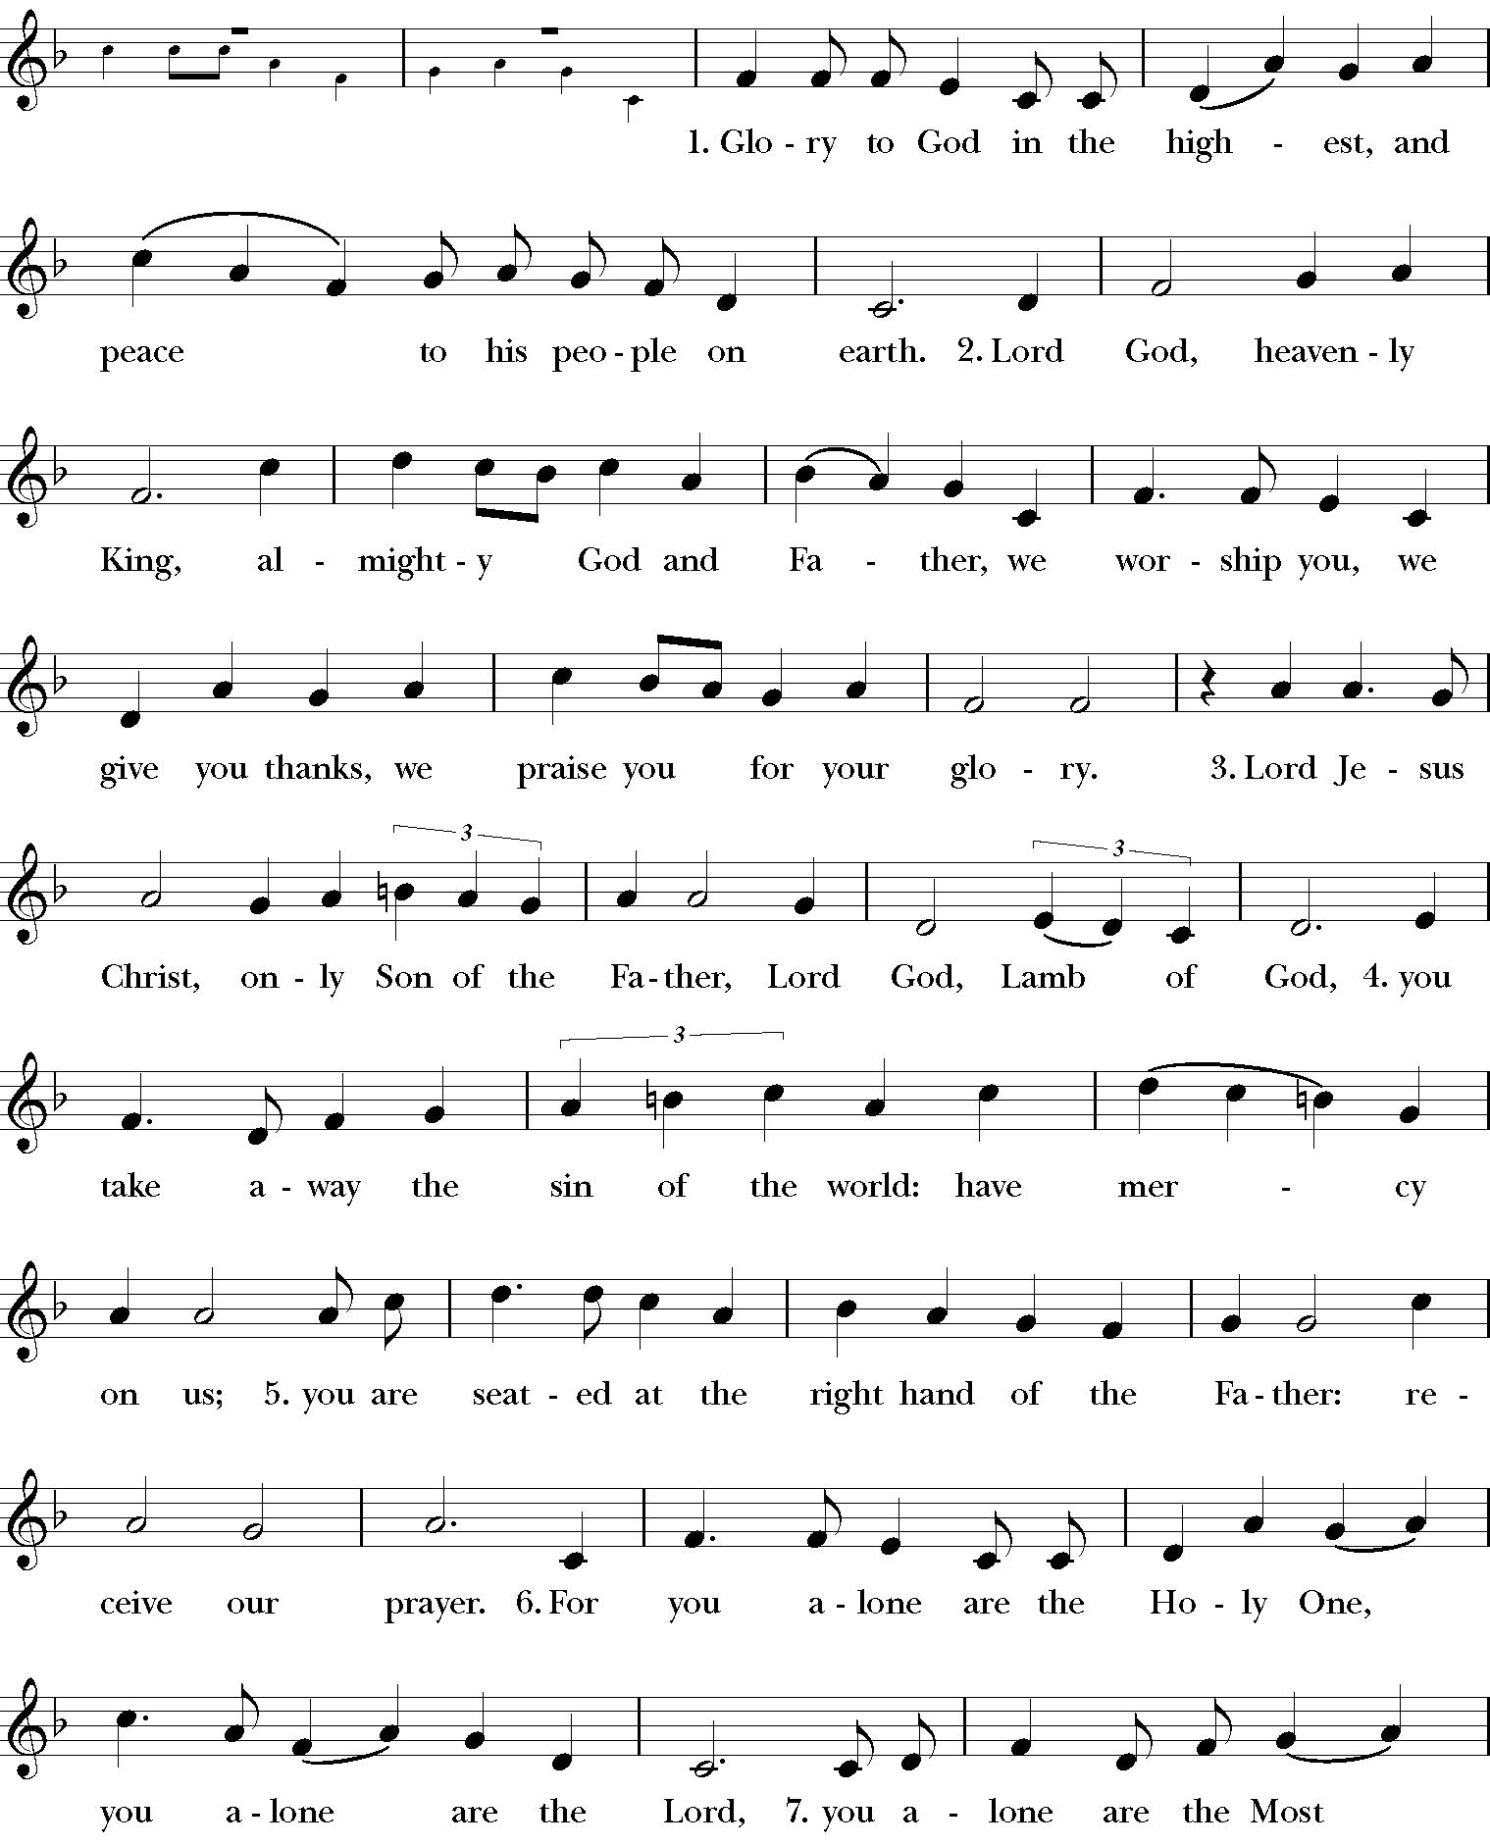
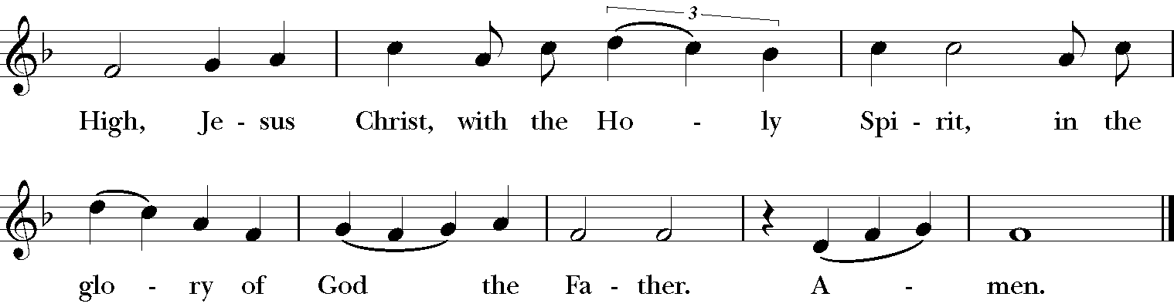

The Collect of the Day

Celebrant: The Lord be with you
All: And also with you
Celebrant: Let us pray together.

All: Grant, O merciful God, that your Church, being gathered together in unity by your Holy Spirit, may show forth your power among all peoples, to the glory of your Name; through Jesus Christ our Lord, who lives and reigns with you and the Holy Spirit, one God, for ever and ever. Amen.

The Lessons
Please be seated

The First Reading: 1 Kings 8:1, 6, 10-11, 22-30, 41-43

Reader: A Reading from First Kings

Solomon assembled the elders of Israel and all the heads of the tribes, the leaders of the ancestral houses of the Israelites, before King Solomon in Jerusalem, to bring up the ark of the covenant of the Lord out of the city of David, which is Zion. Then the priests brought the ark of the covenant of the Lord to its place, in the inner sanctuary of the house, in the most holy place, underneath the wings of the cherubim. And when the priests came out of the holy place, a cloud filled the house of the Lord, so that the priests could not stand to minister because of the cloud; for the glory of the Lord filled the house of the Lord.

Then Solomon stood before the altar of the Lord in the presence of all the assembly of Israel, and spread out his hands to heaven. He said, “O Lord, God of Israel, there is no God like you in heaven above or on earth beneath, keeping covenant and steadfast love for your servants who walk before you with all their heart, the covenant that you kept for your servant my father David as you declared to him; you promised with your mouth and have this day fulfilled with your hand. Therefore, O Lord, God of Israel, keep for your servant my father David that which you promised him, saying, ‘There shall never fail you a successor before me to sit on the throne of Israel, if only your children look to their way, to walk before me as you have walked before me.’ Therefore, O God of Israel, let your word be confirmed, which you promised to your servant my father David.

“But will God indeed dwell on the earth? Even heaven and the highest heaven cannot contain you, much less this house that I have built! Regard your servant’s prayer and his plea, O Lord my God, heeding the cry and the prayer that your servant prays to you today; that your eyes may be open night and day toward this house, the place of which you said, ‘My name shall be there,’ that you may heed the prayer that your servant prays toward this place. Hear the plea of your servant and of your people Israel when they pray toward this place; O hear in heaven your dwelling place; heed and forgive.

“Likewise when a foreigner, who is not of your people Israel, comes from a distant land because of your name —for they shall hear of your great name, your mighty hand, and your outstretched arm—when a foreigner comes and prays toward this house, then hear in heaven your dwelling place, and do according to all that the foreigner calls to you, so that all the peoples of the earth may know your name and fear you, as do your people Israel, and so that they may know that your name has been invoked on this house that I have built.

Reader: Hear what the Spirit is saying to God’s people.
All: | Thanks be to God.

The Psalm: 84 (said in unison)

1 How dear to me is your dwelling, O Lord of hosts! *
My soul has a desire and longing for the courts of the Lord;
my heart and my flesh rejoice in the living God.
2 The sparrow has found her a house
and the swallow a nest where she may lay her young; *
by the side of your altars, O Lord of hosts,
my King and my God.
3 Happy are they who dwell in your house! *
they will always be praising you.
4 Happy are the people whose strength is in you! *
whose hearts are set on the pilgrims' way.
5 Those who go through the desolate valley will find it a place of springs, *
for the early rains have covered it with pools of water.
6 They will climb from height to height, *
and the God of gods will reveal himself in Zion.
7 Lord God of hosts, hear my prayer; *
hearken, O God of Jacob.
8 Behold our defender, O God; *
and look upon the face of your Anointed.
9 For one day in your courts is better than a thousand in my own room, *
and to stand at the threshold of the house of my God
than to dwell in the tents of the wicked.
10 For the Lord God is both sun and shield; *
he will give grace and glory;
11 No good thing will the Lord withhold *
from those who walk with integrity.
12 O Lord of hosts, *
happy are they who put their trust in you!

The Second Reading: Ephesians 6:10-20
The Reader: A reading from Ephesians

Be strong in the Lord and in the strength of his power. Put on the whole armor of God, so that you may be able to stand against the wiles of the devil. For our struggle is not against enemies of blood and flesh, but against the rulers, against the authorities, against the cosmic powers of this present darkness, against the spiritual forces of evil in the heavenly places. Therefore take up the whole armor of God, so that you may be able to withstand on that evil day, and having done everything, to stand firm. Stand therefore, and fasten the belt of truth around your waist, and put on the breastplate of righteousness. As shoes for your feet put on whatever will make you ready to proclaim the gospel of peace. With all of these, take the shield of faith, with which you will be able to quench all the flaming arrows of the evil one. Take the helmet of salvation, and the sword of the Spirit, which is the word of God.

Pray in the Spirit at all times in every prayer and supplication. To that end keep alert and always persevere in supplication for all the saints. Pray also for me, so that when I speak, a message may be given to me to make known with boldness the mystery of the gospel, for which I am an ambassador in chains. Pray that I may declare it boldly, as I must speak.

Reader: Hear what the Spirit is saying to God’s people.
All: | Thanks be to God.

The Gradual Hymn: 440 Blessed Jesus, at thy word
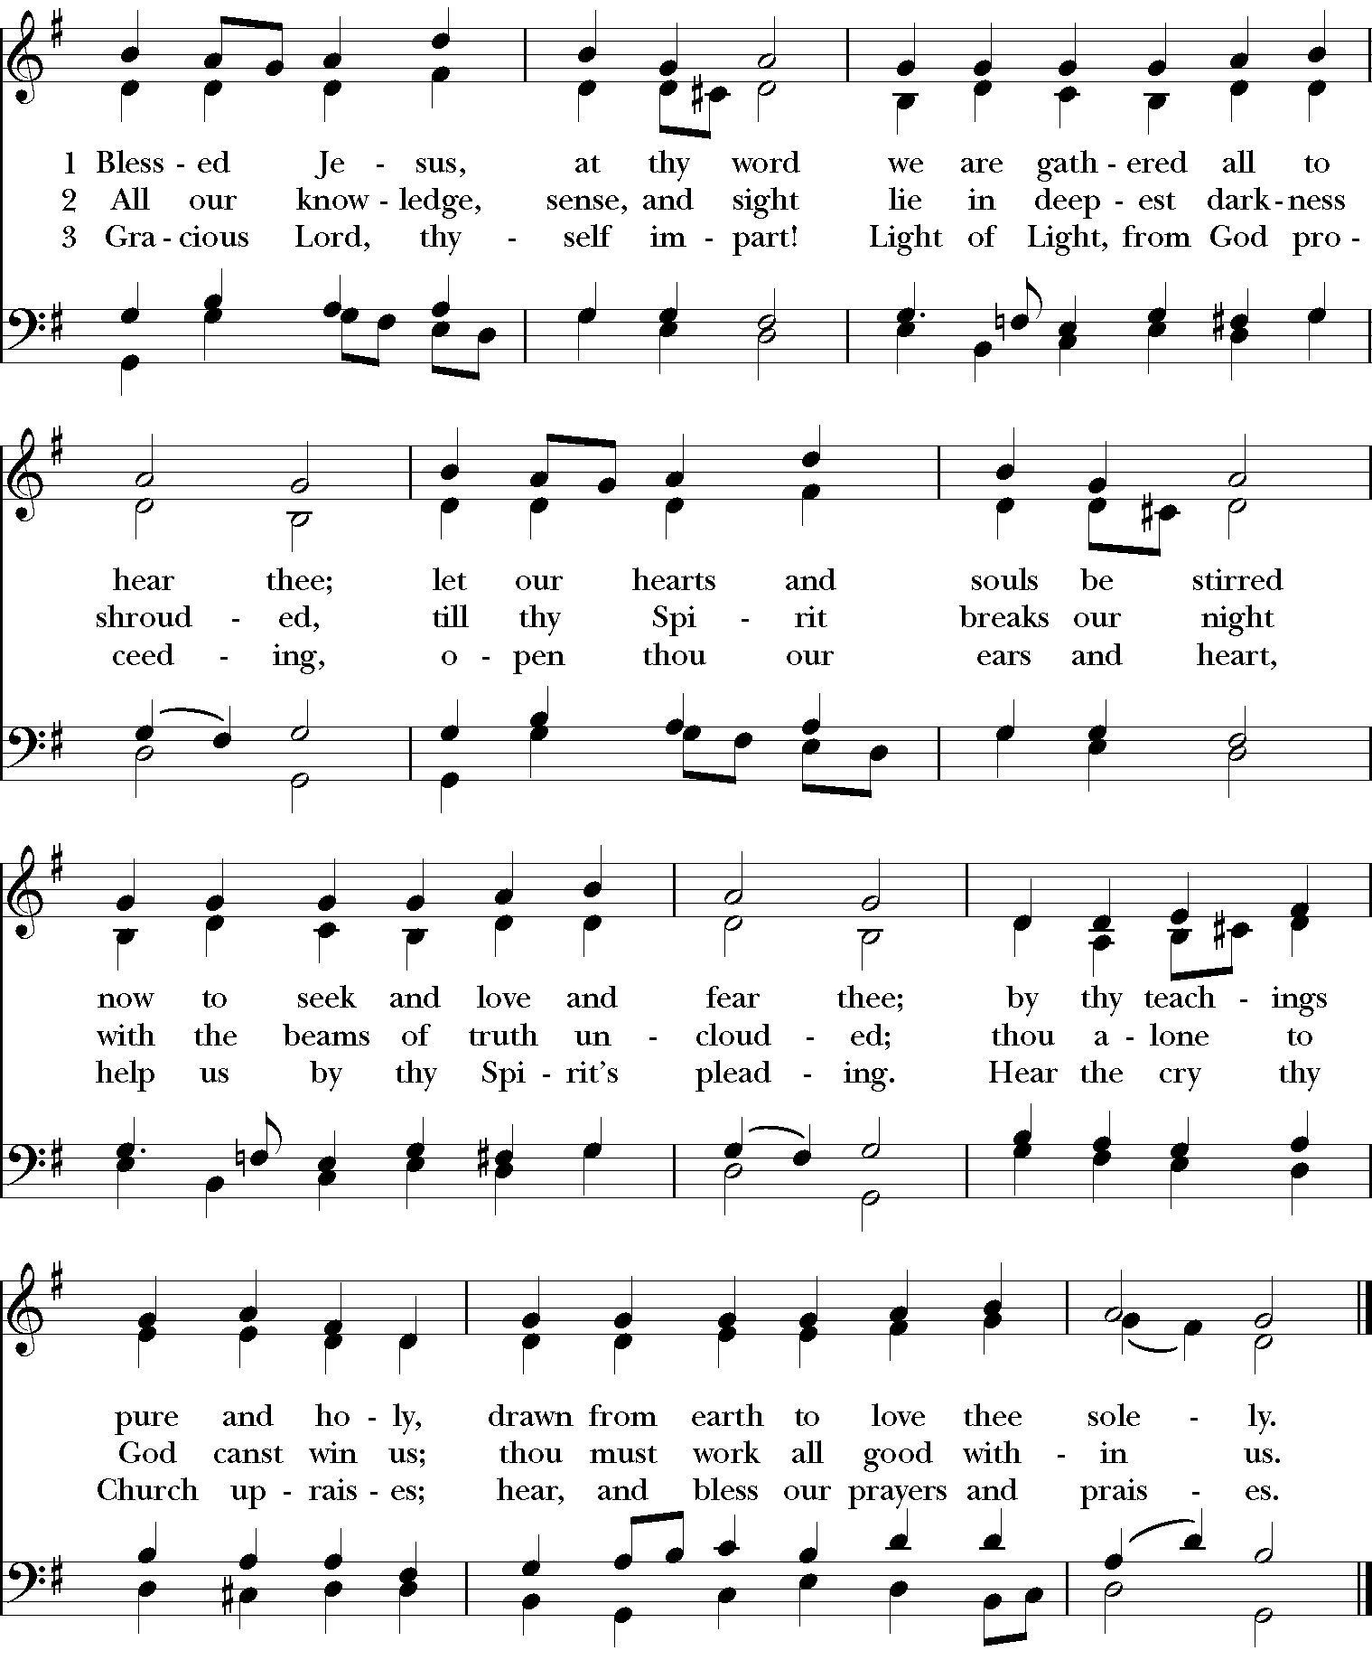

The Gospel: John 6:56-59
Please stand.

Celebrant: The Holy Gospel of our Lord Jesus Christ according to John
All: Glory to you, Lord Christ.

Jesus said, “Those who eat my flesh and drink my blood abide in me, and I in them. Just as the living Father sent me, and I live because of the Father, so whoever eats me will live because of me. This is the bread that came down from heaven, not like that which your ancestors ate, and they died. But the one who eats this bread will live forever.” He said these things while he was teaching in the synagogue at Capernaum.

When many of his disciples heard it, they said, “This teaching is difficult; who can accept it?” But Jesus, being aware that his disciples were complaining about it, said to them, “Does this offend you? Then what if you were to see the Son of Man ascending to where he was before? It is the spirit that gives life; the flesh is useless. The words that I have spoken to you are spirit and life. But among you there are some who do not believe.” For Jesus knew from the first who were the ones that did not believe, and who was the one that would betray him. And he said, “For this reason I have told you that no one can come to me unless it is granted by the Father.”

Because of this many of his disciples turned back and no longer went about with him. So Jesus asked the twelve, “Do you also wish to go away?” Simon Peter answered him, “Lord, to whom can we go? You have the words of eternal life. We have come to believe and know that you are the Holy One of God.”

Celebrant: The Gospel of the Lord.
All: | Praise to you, Lord Christ.

The Sermon
Please be seated.

The Nicene Creed (BCP p. 358)
Please stand.

We believe in one God,
the Father, the Almighty,
maker of heaven and earth,
of all that is, seen and unseen.
We believe in one Lord, Jesus Christ,
the only Son of God,
eternally begotten of the Father,
God from God, Light from Light,
true God from true God,
begotten, not made,
of one Being with the Father.
Through him all things were made.
For us and for our salvation
he came down from heaven:
by the power of the Holy Spirit
he became incarnate from the Virgin Mary,
and was made man.
For our sake he was crucified under Pontius Pilate;
he suffered death and was buried.
On the third day he rose again
in accordance with the Scriptures;
he ascended into heaven
and is seated at the right hand of the Father.
He will come again in glory to judge the living and the dead,
and his kingdom will have no end.
We believe in the Holy Spirit, the Lord, the giver of life,
who proceeds from the Father and the Son.
With the Father and the Son he is worshiped and glorified.
He has spoken through the Prophets.
We believe in one holy catholic and apostolic Church.
We acknowledge one baptism for the forgiveness of sins.
We look for the resurrection of the dead,
and the life of the world to come. Amen.

The Prayers of the People (The Book of Common Prayer Form III)

Intercessor: Father, we pray for your holy Catholic Church;
All: That we all may be one.

Intercessor: Grant that every member of the Church may truly and humbly serve you;
All: That your Name may be glorified by all people.

Intercessor: We pray for all bishops, priests, and deacons;
All: That they may be faithful ministers of your Word and Sacraments.

Intercessor: We pray for all who govern and hold authority in the nations
of the world;
All: That there may be justice and peace on the earth.

Intercessor: Give us grace to do your will in all that we undertake;
All: That our works may find favor in your sight.

Intercessor: Have compassion on those who suffer from any grief or trouble;
All: That they may be delivered from their distress.

Intercessor: Give to the departed eternal rest.
All: Let light perpetual shine upon them.

Intercessor: We praise you for your saints who have entered into joy;
All: May we also come to share in your heavenly kingdom.

Intercessor: Let us pray for our own needs and those of others.

The People may add their own petitions.

The Celebrant adds a concluding Collect.

The Confession of Sin (BCP p. 359)

Celebrant: Let us confess our sins against God and our neighbor.

Silence may be kept.

All: Most merciful God,
we confess that we have sinned against you
in thought, word, and deed,
by what we have done,
and by what we have left undone.
We have not loved you with our whole heart;
we have not loved our neighbors as ourselves.
We are truly sorry and we humbly repent.
For the sake of your Son Jesus Christ,
have mercy on us and forgive us;
that we may delight in your will,
and walk in your ways,
to the glory of your Name. Amen.

Celebrant: Almighty God have mercy on you, forgive you all your sins
through our Lord Jesus Christ, strengthen you in all
goodness, and by the power of the Holy Spirit keep you in
eternal life. Amen.

The Peace
Please pass the pass by nodding or bowing to those around you. Please do not shake hands or hug any other worshippers.

Celebrant: The peace of the Lord be always with you.
All: | And also with you.

The Holy Communion

The Offertory
Celebrant: Let us with gladness present the offerings and oblations of our life and
labor to the Lord.

The Offertory Hymn: 517 How lovely is thy dwelling-place
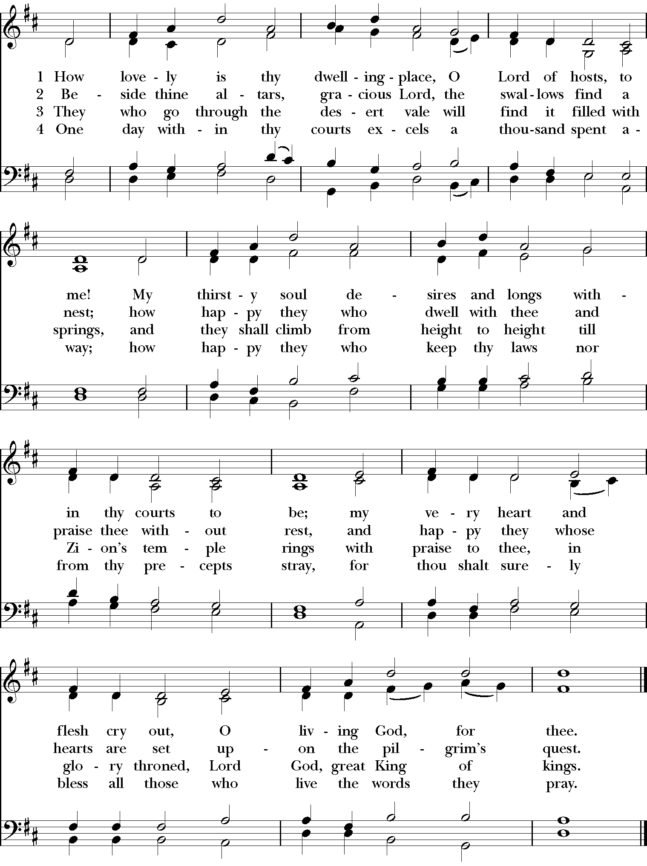

The Presentation Hymn: 380 Praise God, from whom all blessings flow
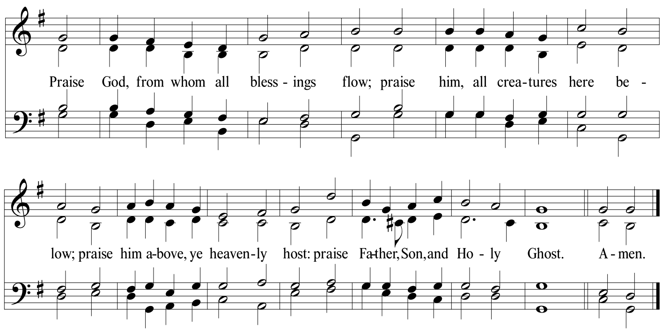

The Great Thanksgiving: Eucharistic Prayer B (BCP, p. 367)

Celebrant: The Lord be with you.
All: And also with you.

Celebrant: Lift up your hearts.
All: We lift them to the Lord.

Celebrant: Let us give thanks to the Lord our God.
All: It is right to give him thanks and praise.

Celebrant: It is right and a good and joyful thing, always and everywhere to give thanks to you, Father Almighty, Creator of heaven and earth. For by water and the Holy Spirit you have made us a new people in Jesus Christ our Lord, to show forth your glory in all the world.

Therefore we praise you, joining our voices with Angels and Archangels and with all the company of heaven, who for ever sing this hymn to proclaim the glory of your Name:
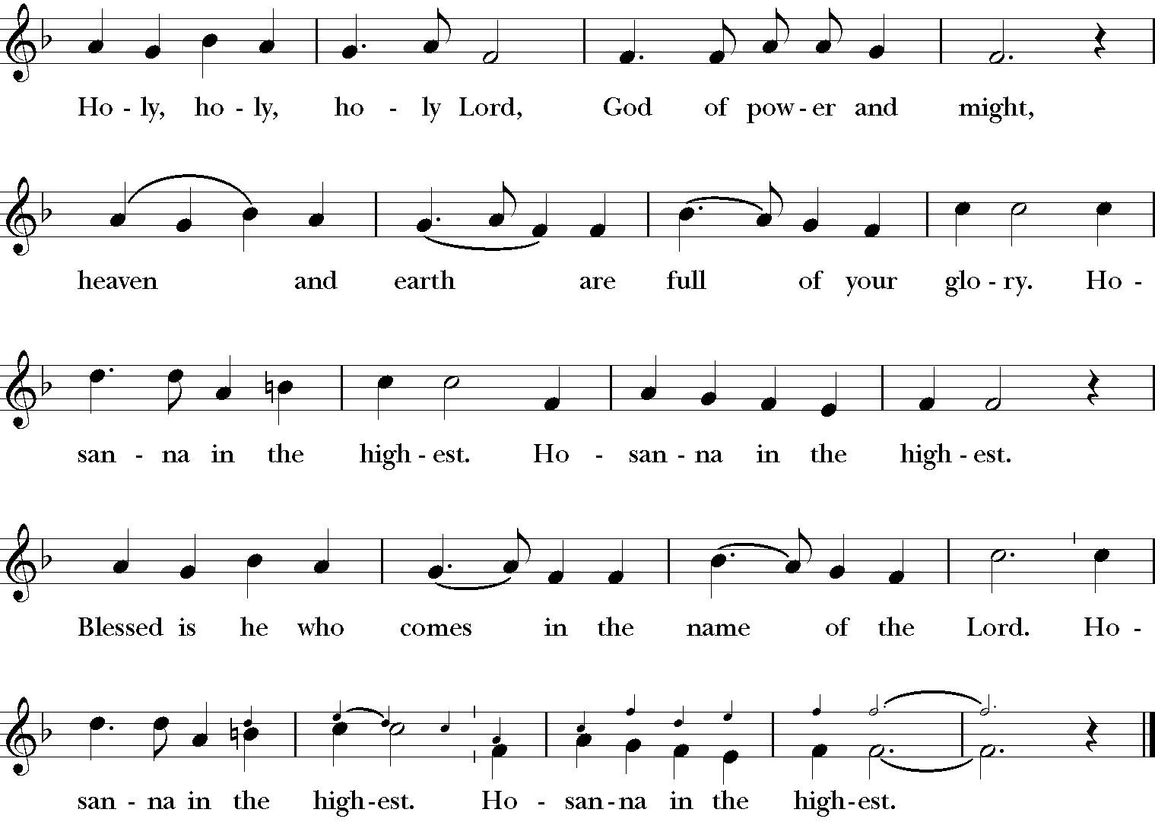
Celebrant: We give thanks to you, O God, for the goodness and love which you
have made known to us in creation; in the calling of Israel to be your people; in your Word spoken through the prophets; and above all in the Word made flesh, Jesus, your Son. For in these last days you sent him to be incarnate from the Virgin Mary, to be the Savior and Redeemer of the world. In him, you have delivered us from evil, and made us worthy to stand before you. In him, you have brought us out of error into truth, out of sin into righteousness, out of death into life.

On the night before he died for us, our Lord Jesus Christ took bread; and when he had given thanks to you, he broke it, and gave it to his disciples, and said, "Take, eat: This is my Body, which is given for you. Do this for the remembrance of me."

After supper he took the cup of wine; and when he had given thanks, he gave it to them, and said, "Drink this, all of you: This is my Blood of the new Covenant, which is shed for you and for many for the forgiveness of sins. Whenever you drink it, do this for the remembrance of me."

Therefore, according to his command, O Father,

All: We remember his death,
We proclaim his resurrection,
We await his coming in glory;
Celebrant: And we offer our sacrifice of praise and thanksgiving to you, O Lord
of all; presenting to you, from your creation, this bread and this wine. We pray you, gracious God, to send your Holy Spirit upon these gifts that they may be the Sacrament of the Body of Christ and his Blood of the new Covenant. Unite us to your Son in his sacrifice, that we may be acceptable through him, being sanctified by the Holy Spirit. In the fullness of time, put all things in subjection under your Christ, and bring us to that heavenly country where, with all your saints, we may enter the everlasting heritage of your sons and daughters; through Jesus Christ our Lord, the firstborn of all creation, the head of the Church, and the author of our salvation.

By him, and with him, and in him, in the unity of the Holy Spirit all honor and glory is yours, Almighty Father, now and for ever. AMEN.

And now, as our Savior Christ has taught us, we are bold to say,

Our Father, who art in heaven,
hallowed be thy Name,
thy kingdom come,
thy will be done,
on earth as it is in heaven.
Give us this day our daily bread.
And forgive us our trespasses,
as we forgive those
who trespass against us.
And lead us not into temptation,
but deliver us from evil.
For thine is the kingdom,
and the power, and the glory,
for ever and ever. Amen.

The Breaking of the Bread

The Celebrant breaks the consecrated Bread. A period of silence is kept.
Then may be sung or said
Celebrant: Alleluia. Christ our Passover is sacrificed for us;
All: Therefore let us keep the feast. Alleluia.

Celebrant: The Gifts of God for the People of God.
Take them in remembrance that Christ died for
you, and feed on him in your hearts by faith,
with thanksgiving.
Communion Hymn: 554 ‘Tis the gift to be simple (with additional verses)
(VERSE)
‘Tis the gift to be simple,
‘Tis the gift to be free,
‘Tis the gift to come down where we want to be,
And when we find ourselves in the place just right,
We’ll be in the valley of love and delight.

(CHORUS)
When true simplicity is gained,
To bow and to bend we shan't be ashamed,
To turn, turn, will be our delight,
‘Til by turning, turning, we come ‘round right.

‘Tis the gift to be gentle,
‘Tis the gift to be fair,
‘Tis the gift to wake and breathe the morning air,
And every day to walk in the path we choose,
‘Tis the gift that we pray we may ne'er come to lose.
(REPEAT CHORUS)

‘Tis the gift to be knowing,
‘Tis the gift to be kind,
‘Tis the gift to wait to hear another’s mind,
That when we speak our feelings we might come out true,
‘Tis the gift for me and the gift for you.
(REPEAT CHORUS)

‘Tis the gift to be loving,
‘Tis the gift best of all,
Like a quiet rain it blesses where it falls,
And if we have the gift we will truly believe,
‘Tis better to give than it is to receive.
(REPEAT CHORUS)

The Postcommunion Prayer (BCP p. 365)

Celebrant: Let us pray.

Eternal God, heavenly Father,
you have graciously accepted us as living members
of your Son our Savior Jesus Christ,
and you have fed us with spiritual food
in the Sacrament of his Body and Blood.
Send us now into the world in peace,
and grant us strength and courage
to love and serve you
with gladness and singleness of heart;
through Christ our Lord. Amen.
The Blessing
The Celebrant Blesses the People.

Recessional Hymn: 530 Spread, O spread, thou mighty word
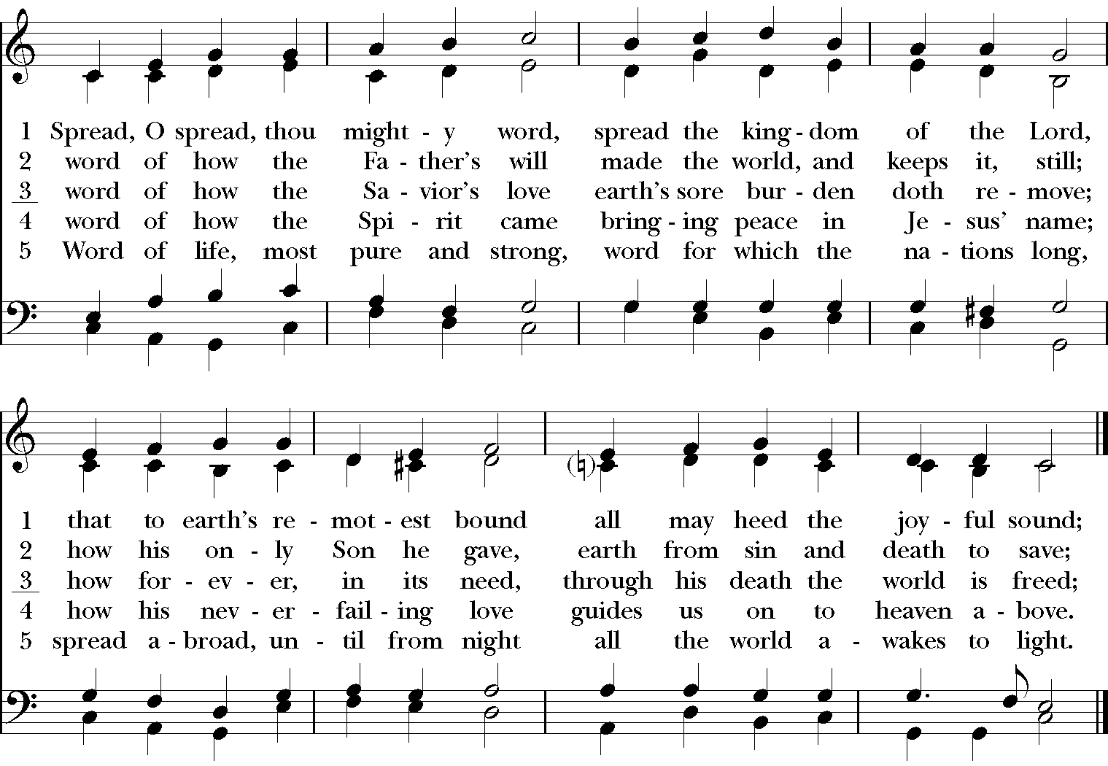
The Dismissal
The Celebrant dismisses the congregation and everyone responds:

All: Thanks be to God.

Postlude

